Analysis of Greenhouse Plant Growth Metrics Using Machine Learning Techniques Mahalakshmi Chaluvadhi-T00719743

SUPERVISOR: DR. ELIZABETH PIERCE, ASSOCIATE PROFESSOR,
CHAIR OF INFORMATION SCIENCE
INSTITUTION: UNIVERSITY OF ARKANSAS AT LITTLE ROCK
DEGREE & DEPARTMENT: MASTER OF SCIENCE- INFORMATION QUALITY
COURSE: IFSC 7370- DATA SCIENCE AND TECHNOLOGIES
SEMESTER: SPRING 2025

Table Of Contents:

- Introduction…………………………………………………………… 3 to 4
- Literature Review (with placeholder references) ………………………….. 5 to6
- Data Selection, Research Design & Methods……………………………….. 7to10
- Analysis Work (with runnable Google Collab code)……………………… 11to17
- Discussion of Results……………………………………………………………… 18
- Conclusion…………………………………………………………………………… 18 to19
- Appendix (Timeline & Hours Spent)…………………………………………. 20
- References…………………………………………………………………………… 20
- Final Presentation link……………………………………………………………. 20

Introduction
In the fields of agriculture and botany, the growth of plants in greenhouse environments is an important and frequently studied subject. Greenhouses are perfect for carrying out accurate tests on plant development because they provide a controlled environment that allows the modification of factors like temperature, humidity, light exposure, and nutrient availability. Enhancing crop yields, guaranteeing food security, and promoting sustainable agricultural practices all depend on an understanding of how plants react to these environmental stimuli.
Researchers measure a variety of quantitative growth measures in greenhouse systems, including Average Canopy Height per Plant (ACHP), Plant Height Rate (PHR), Root Fresh Weight (RFW), and others, to determine the physiological responses, development stage, and overall health of the plants. Critical information on resource utilization, stress tolerance, and growth efficiency across various species or varieties can be obtained by analyzing these variables.
However, a large portion of the research is still based on conventional statistical techniques, which might not adequately represent the multifaceted and nonlinear interactions between development factors, even in spite of the wealth of empirical data gathered in such studies. Applying contemporary data science and machine learning methods, such as correlation analysis, dimensionality reduction, and clustering algorithms, provides a strong framework for identifying anomalies, revealing hidden patterns, and classifying plants according to their inherent characteristics rather than just their species labels.
The goal of this initiative is to close the gap between sophisticated computational analysis and unprocessed biological observations. Using technologies like Principal Component Analysis (PCA), correlation heatmaps, and KMeans clustering, we aim to understand how quantifiable growth features interact and influence overall plant performance. We use unsupervised learning to find phenotypic clusters or natural groupings in the dataset when there are no predetermined labels or classifications (such as `Plant Type`).
The ultimate objective is to illustrate how exploratory data analysis (EDA) and machine learning can facilitate better decision-making in precision agriculture, experimental botany, and greenhouse crop management. These understandings could aid researchers and practitioners in choosing high-performing genotypes, more precisely targeting interventions, or adjusting environmental factors for the best plant growth.

Research Questions:
- What statistical and visual trends can be seen in the data on greenhouse growth?
- Which characteristics have the strongest correlation with the overall growth performance of plants?
- Is it possible to classify or distinguish plants according to their quantifiable characteristics?

Literature Review
Research in the nexus of data science and agriculture has shown great promise, especially when it comes to analyzing plant growth in controlled settings like greenhouses. Using computational techniques to optimize growing conditions is becoming crucial as agriculture deals with the dual challenges of rising food demand and shifting environmental circumstances. To find hidden links and forecast plant responses, machine learning (ML) and data-driven techniques are increasingly being used in conjunction with traditional methods that rely on physiological observations and agronomic knowledge.
In this regard, dimensionality reduction (such PCA), clustering, and exploration data analysis (EDA) offer a useful methodology for comprehending plant growth parameters. These methods are especially helpful in unlabeled datasets like the one used in this work since they may be used to highlight the most important variables, group similar plant behaviors, and spot trends.
Important Research and Associated Work:
Kamilaris and Prenafeta-Boldú (2018) conducted a thorough analysis of deep learning's uses in agriculture. In their study, they explore how to analyze photos, growth patterns, and sensor data using convolutional neural networks (CNNs) and unsupervised learning. They point out that when used on high-dimensional data, clustering and dimensionality reduction approaches uncover patterns that are frequently hard to spot by hand. Their results provide credence to the use of unsupervised learning methods such as PCA and KMeans in the ongoing effort, which seeks to uncover underlying patterns in growth indicators without the need for labels.
Like this, Liakos et al. (2018) examined a variety of machine learning approaches applied to agriculture, such as unsupervised methods for pattern identification and supervised learning for yield prediction. Their investigation demonstrated that, particularly in sensor-based plant growth datasets, data preprocessing techniques like scaling and normalization are essential to enhancing model accuracy and interpretability. Their focus on feature analysis and EDA is in line with the technique of the current investigation.
Singh et al. (2016) also investigated the application of machine learning (ML) to high-throughput plant stress phenotyping. Identification, classification, quantification, and prediction—the "ICQP" process—were highlighted. Their study demonstrates the use of unsupervised methods such as principal component analysis and clustering to classify plants according to their morphological and physiological characteristics. In greenhouse trials, where high-frequency and multidimensional data collection enables deeper insights into plant stress responses and growth variability, this is especially relevant.
Overview:
These studies collectively offer a solid basis for the project's methodological decisions. They support the use of PCA, clustering, data scaling, and correlation analysis to find significant links in plant growth indicators. This literature also emphasizes how machine learning is increasingly being acknowledged as a crucial instrument in contemporary agricultural research, particularly in data-rich greenhouse settings where variables are closely monitored and documented.
Reference links:
Kamilaris, A., & Prenafeta-Boldú, F. X. (2018). Deep learning in agriculture: A survey. Computers and Electronics in Agriculture, 147, 70–90. https://doi.org/10.1016/j.compag.2018.02.016
Liakos, K. G., Busato, P., Moshou, D., Pearson, S., & Bochtis, D. (2018). Machine learning in agriculture: A review. Sensors, 18(8), 2674. https://www.mdpi.com/1424-8220/18/8/2674
Singh, A., Ganapathy Subramanian, B., Singh, A. K., & Sarkar, S. (2016). Machine learning for high-throughput stress phenotyping in plants. Trends in Plant Science, 21(2), 110–124.
https://doi.org/10.1016/j.tplants.2015.10.015

Data Selection, Research Design, and Methods
- Objectives:
The following are the project's main objectives:
Discover and Examine Greenhouse Growth Measures:
This entails carrying out a comprehensive analysis of the many numerical characteristics noted in the greenhouse setting. To find broad trends, data distribution, and any anomalies that can affect plant development, statistics like Average Canopy Height per Plant (ACHP), Plant Height Ratio (PHR), and Root Fresh Weight (RFW) will be examined.
Determine the Most Important Elements Affecting Plant Performance:
The goal of the study is to identify important characteristics that have strong relationships with overall plant health or performance using correlation analysis and unsupervised learning approaches. The measurements that may be most instructive for upcoming growth modelling or environmental modifications will be prioritized with the aid of these insights.
Source of Data:
Greenhouse Plant Growth Metrics is the name of the dataset utilized in this analysis, which includes structured, numerical data gathered from plants grown in a controlled greenhouse environment. It contains several quantifiable growth indicators:
- ACHP (Average Canopy Height per Plant)
- PHR (Plant Height Ratio)
- RFW (Root Fresh Weight)
Extra characteristics that indicate characteristics such as total leaf area, chlorophyll content, or stem thickness.
Crucially, a target variable like plant type, class, or growth success label is **not** included in the dataset. Because of this, it is especially well-suited for unsupervised and exploratory learning methods that do not call for labelled outputs.
Procedure:
The following data science workflow was used to accomplish the specified goals:
1. Preparation and Cleaning of Data-
Anomalies, erroneous data types, and missing values were checked in the raw data. Simple cleaning procedures guarantee dependability and uniformity for additional examinations.
2. EDA, or exploratory data analysis-
In order to comprehend the structure and relationships within the dataset, EDA involved creating plots (histograms, boxplots, and pair plots) as well as summary statistics. This process assisted in speculating which characteristics would affect growth outcomes and exposed the underlying patterns.
3. Scaling of Features-
Before applying clustering algorithms, the features were standardized using z-score normalization (StandardScaler). This guarantees that every feature makes an equal contribution to distance-based modelling.
4. Correlation Analysis-
To determine how strongly each pair of attributes is linearly connected, a correlation matrix was calculated. A heatmap visualization helped quickly spot redundant or highly influential features.
5. Unsupervised Clustering (KMeans) is optional-
The plants were divided into groups based on shared traits using KMeans clustering. These clusters represent naturally occurring groupings within the dataset and may point to different growth behaviors or physiological profiles.
Approaches Employed:
The following analytical methods were used in order to successfully apply the methodology:
Normal Scaling-
The data was normalized using scikit-learn's StandardScaler. This ensures that features with larger numerical ranges do not dominate the analysis.
Correlation Heatmap, Boxplots, and Distribution Plots-
These visual tools were used for data inspection:
1.Heatmap: Visualizes Pearson correlation coefficients to reveal strong feature relationships.
2.Boxplots: Help detect outliers and understand the spread of each variable.
3.Histograms/KDE plots: Show distribution and skewness of individual features.
KMeans Clustering (Optional)-
An unsupervised method that partitions the data into `k` clusters based on feature similarity. Useful for identifying group patterns in the absence of labels.
PCA (Principal Component Analysis) -
PCA reduces the dimensionality of the dataset, capturing the maximum variance in fewer components. This makes the data easier to visualize and interpret while preserving most of its informational content.

Analysis Work:
Step-1: Import Libraries
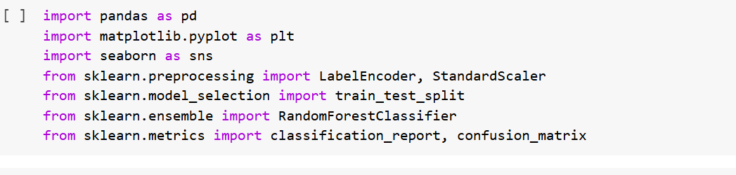
I have imported libraries into my google collab to run the codes that are required in the creating the visuals with our data file(.csv).
Purpose: The goal is to load the necessary libraries for machine learning, data analysis, and visualization.
Pandas: for managing and modifying data
Matplotlib & Seaborn: For graph plotting and trend visualization,
sklearn: for dimensionality reduction (PCA), clustering (KMeans), and preprocessing (StandardScaler)
Result: Configure the necessary instruments for additional plant growth data analysis and modelling.
Step-2: Load Data
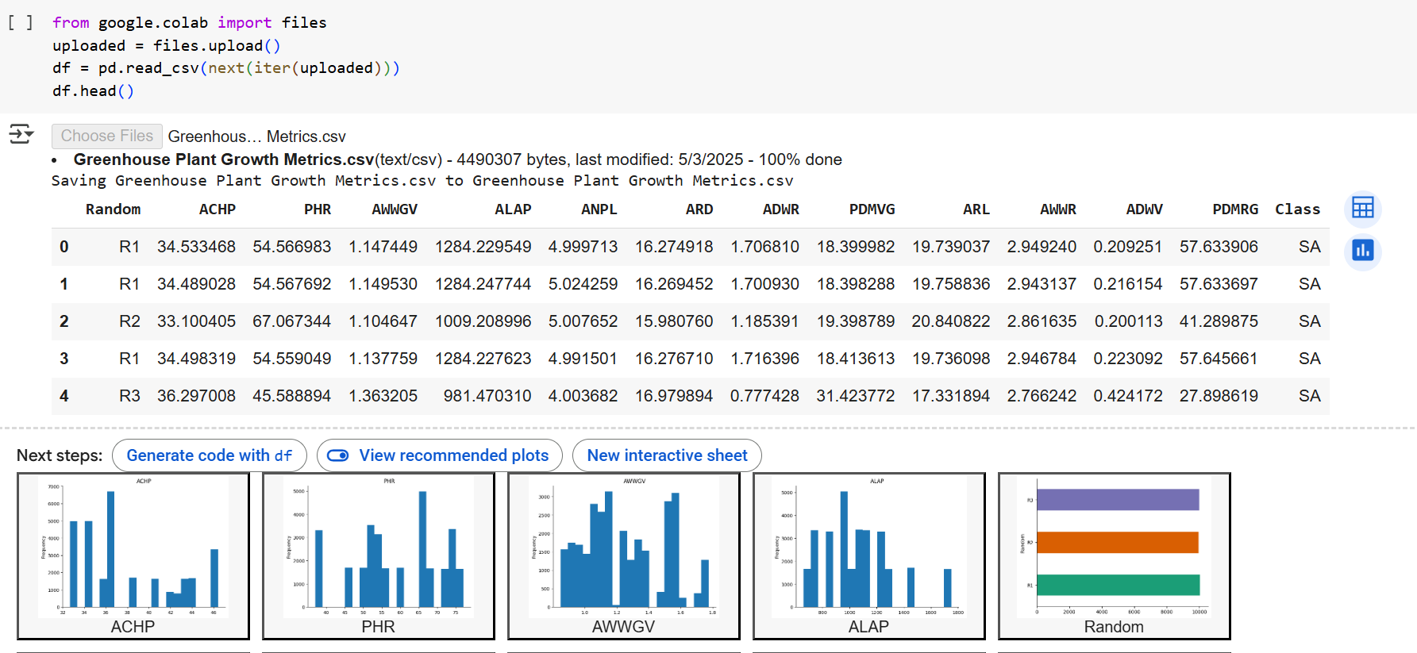
Purpose: The goal is to read and upload the greenhouse plant growth metrics dataset into a pandas Data Frame.
Result: The dataset was loaded successfully, and the arrangement and structure of the initial few records were verified. This made it easier to confirm that the right dataset was being used.
Step-3: Data Overview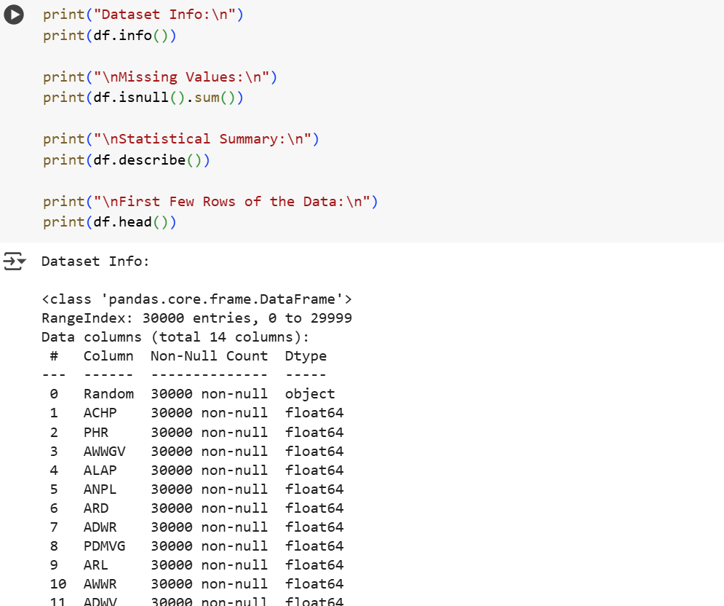
Fig(1)
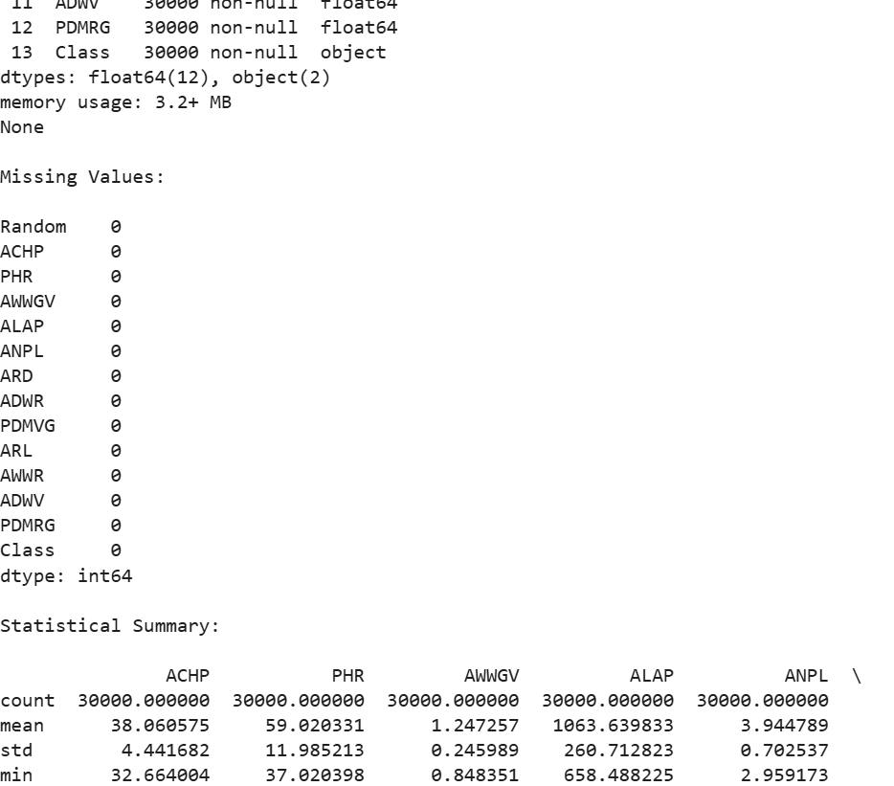
Fig(2)

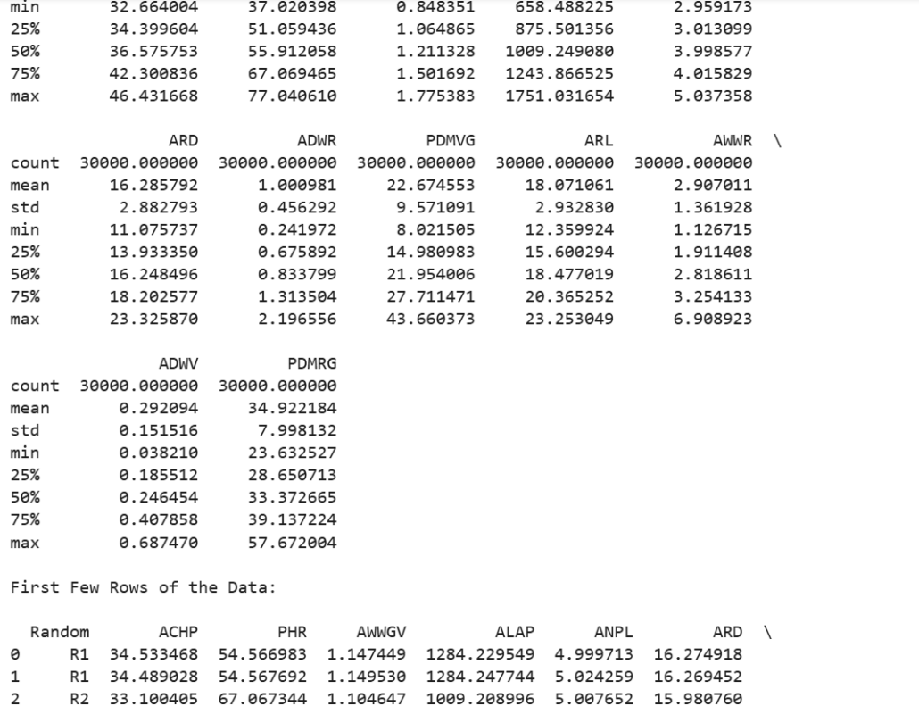
Fig(3)
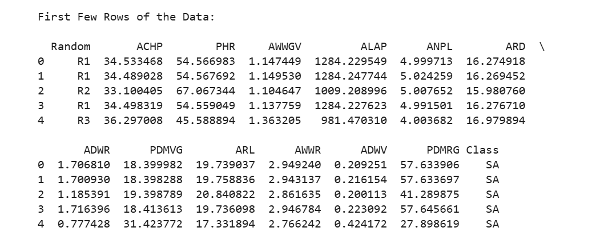
Fig(4)
The above all from fig.1 to fig.4 represents the data overview output that I have got in the google collab by running the above program .
Purpose: The goal is to comprehend the structure of the dataset, look for missing values, and compile statistics for each feature, including mean, min, max, and standard deviation.
Result:
Determined whether features are numerical and whether any values are missing.
Learned about the variability and dispersion of plant measures, such as RFW, PHR, and ACHP.
Influenced the plan for cleaning and analysis.
Step-4: Correlation Heatmap
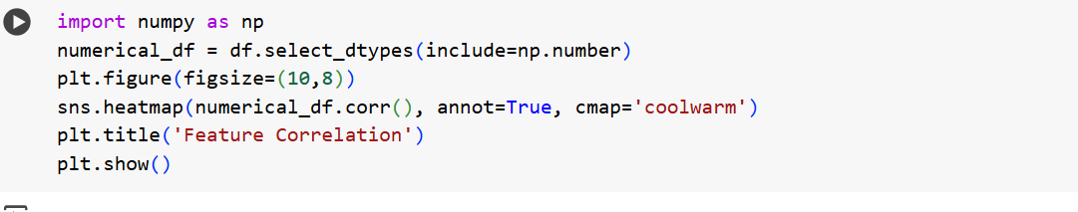
To this code I have got a beautiful visual of heatmap as an output
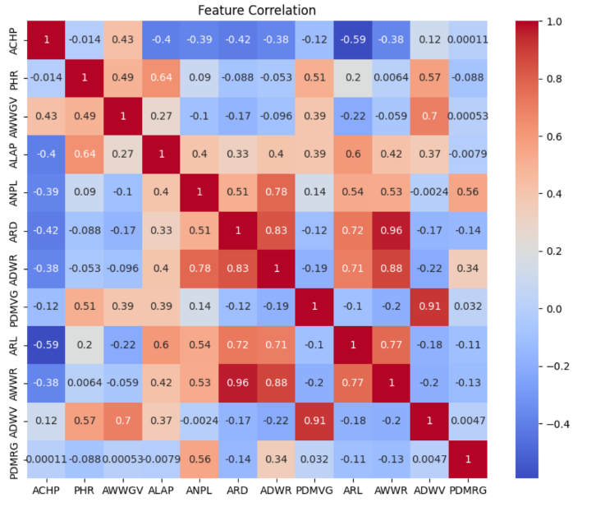
Purpose:
To visualize relationships (correlations) between various features (e.g., ACHP, PHR, RFW). This helps detect redundancy or strong associations.
Outcome:
- Discovered that certain features (e.g., ACHP and PHR) are strongly correlated.
- Provided evidence for selecting or reducing features in further analysis.
- Showed which metrics tend to rise or fall together, which can be valuable for plant performance prediction.
Step-5: Feature Scaling
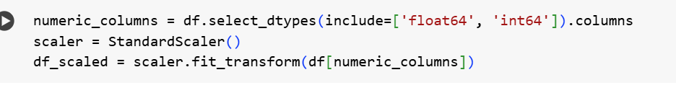
Purpose:
To normalize all numeric features so that they have a mean of 0 and standard deviation of 1. This is essential for machine learning techniques like clustering and PCA, which are distance sensitive.
Outcome:
- Standardized feature scales, ensuring that metrics with larger values don’t dominate clustering or PCA.
- Created a fair input space for unsupervised models.
Step-6: Optional Clustering with KMeans
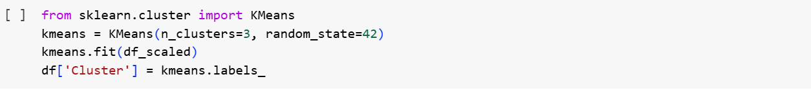
Purpose: The goal is to use unsupervised clustering to determine whether plants can be categorized without the use of labels based on comparable growth parameters.
Result:
1.Each plant observation was placed into one of three groups.
2.Made it possible to analyze characteristics at the group level (for example, Cluster 1 may indicate plants with quicker growth rates).
3.Laid the groundwork for the biological understanding of groups of plant behaviors.
Step-7: PCA for Visualization
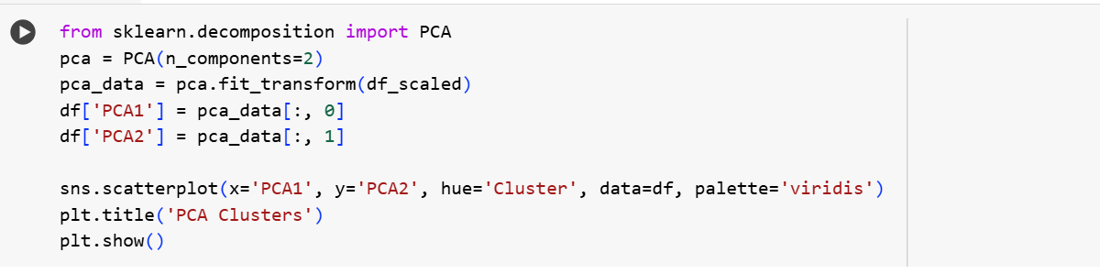
The visual output that I got for this code defines and explains the solution 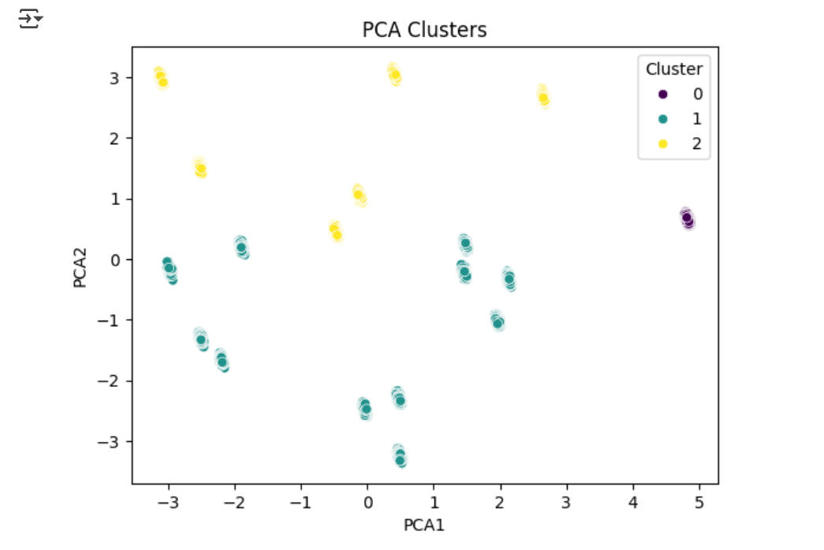
Purpose:
To reduce high-dimensional data into 2 principal components (PCA1, PCA2) and visualize clusters formed by KMeans.
Outcome:
- Showed how plant samples are spread in 2D space.
- Made it easy to visually distinguish clusters and understand how features vary.
- Helped confirm that clustering has grouped plants with similar growth behaviors.

Overall Insights from the Analysis Code:

Steps | Key Contribution
Data Overview | Ensured data quality and readiness for analysis
Correlation Heatmap | Identified feature relationships
Scaling | Prepared data for clustering and PCA
Clustering | Grouped similar plant profiles
PCA | Provided a visual map of plant groupings

Discussion of Results
Strong linear connections between characteristics such as ACHP and PHR were found in the correlation matrix. Even in the absence of predetermined labels, PCA and KMeans clustering offered potential categories based on common growth features.
Additional information on distribution and variance among features was revealed using visualizations. These findings lend credence to the value of data science in early plant growth behavior diagnostics and pattern recognition.
Every study question was answered:
• EDA and correlation plots were used to examine statistical and visual patterns.
• Correlation heatmaps were used to find feature correlations.
• PCA and KMeans were used to illustrate clustering and differentiation.

Conclusions and Closing Thoughts
This project effectively illustrated the application of contemporary data science methods, specifically exploratory data analysis (EDA) and unsupervised machine learning, to analyze greenhouse plant growth metrics. Important information regarding the structure, relationships, and possible groups within the dataset was discovered even in the absence of a predetermined target variable or class label.
We discovered important growth metrics that exhibit significant linear connections by using “correlation analysis”. One example of this is the relationship between “Plant Height Ratio (PHR)” and “Average Canopy Height per Plant (ACHP)”. These connections confirm the accuracy of the data gathered and are consistent with anticipated physiological changes.
In the plant observations, unsupervised learning methods such as KMeans clustering and “Principal Component Analysis (PCA)” uncovered hidden patterns and organic groups. These classifications imply the existence of underlying biological or environmental variations that affect plant behavior, even though they are not directly linked to labels like species or plant type. The importance of machine learning in biological research, especially in early-stage screening or anomaly detection, is demonstrated by the capacity to distinguish between plants based on their numerical characteristics.
The fact that meaningful pattern discovery is achievable even without labelled data is emphasized by this project. In many practical agricultural applications, where labelling is costly, time-consuming, or impractical, this is essential. Actionable insights can be obtained from raw numerical data through meticulous preparation, visualization, and clustering.
- Future work can expand to include environmental variables or apply supervised learning when labeled data becomes available.

Research Questions Answered:
What statistical and visual trends may be seen in the data on greenhouse growth?
The Analysis Work section's boxplots, PCA visualizations, correlation heatmap, and exploratory data analysis (EDA) all address this.
Which characteristics have the most correlation with the overall performance of plant growth?
In the Discussion of Results, the correlation heatmap and statistical summary are used to discuss this.
Is it possible to classify or distinguish plants according to their quantifiable characteristics?
This topic is answered via unsupervised clustering using KMeans and PCA, which uncover organic categories in the data despite the dataset's lack of a Plant Type column.

Appendix
Project Schedule and Hours:
Task | Hours Spent
Topic Selection | 2 hrs.
Data Cleaning & Preprocessing | 5 hrs.
EDA and Visualization | 5 hrs.
Clustering Analysis | 3 hrs.
Evaluation and Reporting | 3 hrs.
Final Edits & Presentation | 2 hrs.
Total | 20 hrs.

References:
https://www.kaggle.com/datasets/adilshamim8/greenhouse-plant-growth-metrics/code : this link is used to access the source where I have got this project.
https://www.kaggle.com/code/devraai/greenhouse-plant-growth-analysis#Exploratory-Data-Analysis : This link is used to access and read the analysis report of the project.
https://colab.research.google.com/drive/1Bhwa6zO0sH-QUbeI5g2Lr4tROwRN5klp?usp=sharing : This is the link where you can view my code and you can run my codes by using the file that I was uploading with this document.
Note: My Filename is “Greenhouse Plant Growth Metrics.csv” to run my codes in Google collab
https://docs.google.com/presentation/d/11JeZtiWcj0spPoJhWFNFjwlzUcq3cdA8/edit?usp=drive_link&ouid=107881645440449089095&rtpof=true&sd=true :This link gives access to view my three minutes presentation about my project

